Note 10001

RANDOMR:

if RANDOM="Y" and DSSCAT="ELIGIBLITY" then do;

if dsdecod not in ("OTHER REASON" ") then randomr = dsterm;
else if dsdecod = "OTHER REASON" then randomr = "OTHER REASON: "||dsterm;
end;

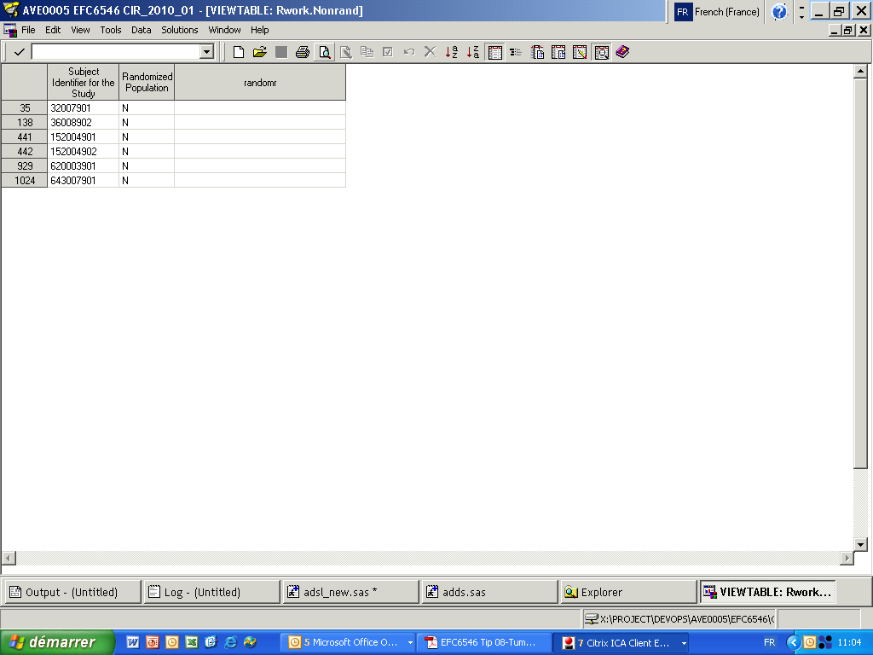

SAFETYR:

if RANDOM="Y" and EXPOSED="N" and DSSCAT="END OF TREATMENT" then do;

if dsdecod not in ("OTHER REASON" "SUBJECT'S REQUEST") then safetyr = dsterm;
else if dsdecod = "OTHER REASON" then safetyr = "OTHER REASON: "||dsterm;
else if dsdecod = "SUBJECT'S REQUEST" then safetyr = "SUBJECT'S REQUEST: "||dsterm;
end;

else if RANDOM="N" then SAFETYR="NOT RANDOMIZED";

ITTR

????

POPPK

???

Note 10002

ENDTROTH:

If the reason for stopping treatment is “Other”, the specify are reclassified as below;

- if specify=” WITHDRAWN” or “CONSENT” then endtroth = 'CONSENT WITHDRAWN';
- if specify=”INVESTIGATOR” or ”PI ” (avec l’espace) or ”PHYSICIAN” or =”CLINICIAN” or ”CONSULTANT” or “INVESTIGATER” or “MEDICAL” or “DOCTOR” or “NO FURTHER BENEFIT” then endtroth ='INVESTIGATOR DECISION'
- if specify=”PATIENT” or ”SUBJECT” or “WISH” then endtroth ='SUBJECT REQUEST’
- if specify=” OTHER” then endtroth ='OTHER’

